MWF-Inetrnational Open GRAND PRIX/Neusiedl Am See/AT,30.09.-01.10.2017.
ACCOMODATION: Deadline 01. 09. 2017.
1.HOTEL BARONKA/Mudrochova 2,835 27 SK- Bratislava – Rača
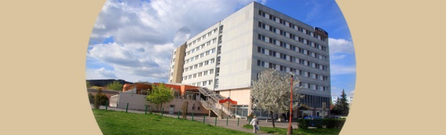
25 rooms
www.baronka.sk

Eur 25,00 per person/3,4,5 person/with breakfast
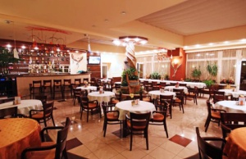
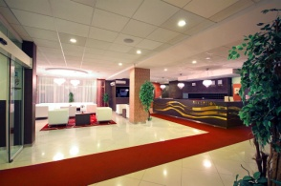
Eur 27,00 per person/ double room / with breakfast
Eur 44,00 single room /with breakfast
Eur 11,50 HB 3-course menu
___________________________________________________________________________

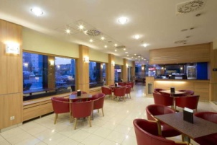
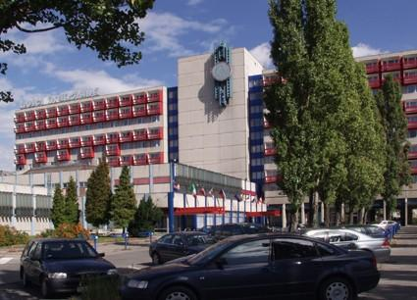
2.HOTEL BRATISLAVA/ Seberíniho 9, 821 03 Bratislava
200 person/ 10 double rooms/ 60 triple rooms/
www.hotelbratislava.sk/
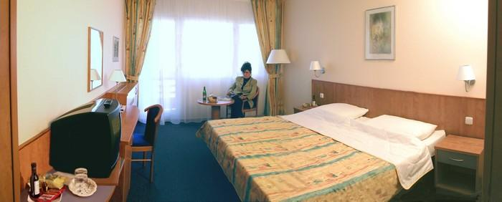
Eur 27,00 per person/double room/ with breakfast
Eur 42,00 single room/with breakfast
Eur 11,50 HB 3-course menu
Eur 09,50 HB 2-course menu

3.HOTEL COLOR/ Pri Starom mýte 3095/1, 831 04 Bratislava
www.hotelcolor.sk
Eur 25,00 per person /Multiple bedroom /with breakfast
Eur 31,00 per person/double room/ with breakfast
Eur 47,00 single room/with breakfast
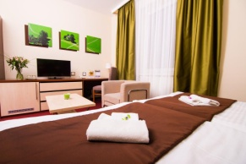
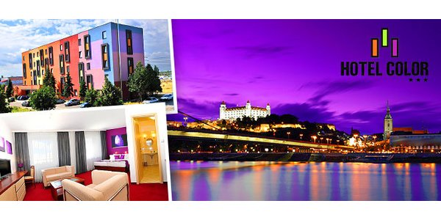
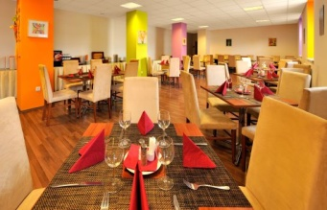
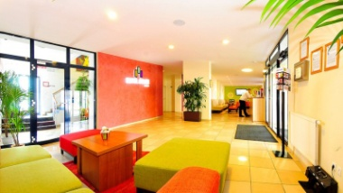

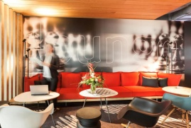
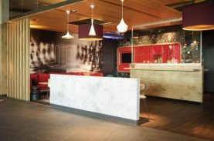
__________________________________________________________________________________
4. IBIS Vienna Airport Hotel S1
Raststation Schwechat S1, 2320 Schwechat
www.ibis.com

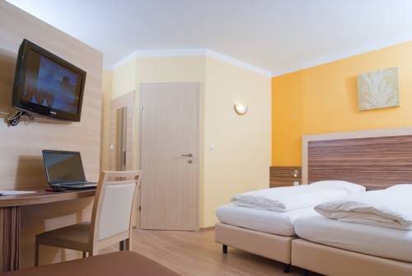
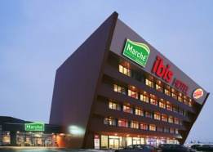
Eur 30,00 per person/double room/ with breakfast
Eur 42,00 single room/with breakfast

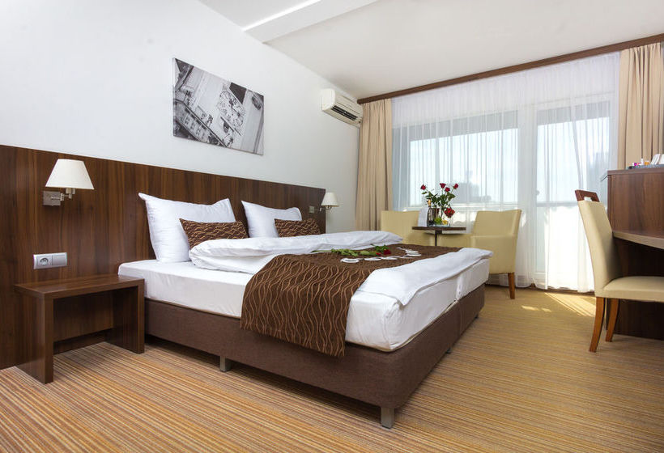
MWF-Inetrnational Open GRAND PRIX/Neusiedl Am See/AT,30.09.-01.10.2017.
ACCOMODATION
APPLICATION FORM
E-mail: majorettes.mwf@gmail.com
-payment of 30% to 01. 09. 2017. /ALL -15. 09. 2017. DEADLINE 01.09.2017.
COUNTRY:
TOWN:
CLUB/DIVISION:
CONTACT PERSON:
ADRESS:
MOB:
E-MAIL:

ACCOMODATION:
DATE: | Hotel for accomodation-  number: /1,2,3,4/ | NUMBER  PERSON FOR  ACCOMODATION: | TOTAL:
29.09.-30.09.2017.
30.09.-01.10.2017.
01.10.-02.10.2017.
ALL:

Date:_____________________ ______________________
Signature:

