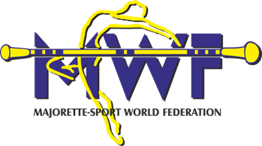

**MWF MEETINGS /15. - 17.01.2016**

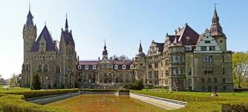

**ACCOMODATION:**

**HOTEL MOSZNA ZAMEK**

**Ul. ZAMKOWA 1, MOSZNA**

[**http://www.moszna-zamek.pl/**](http://www.moszna-zamek.pl/)

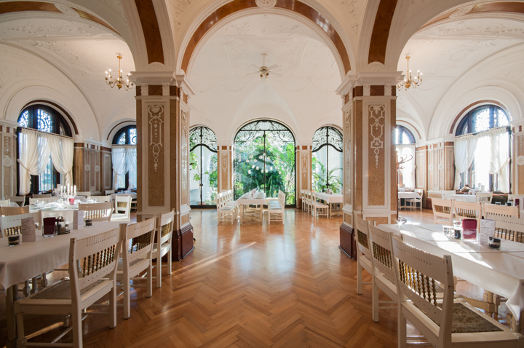

**___________________________________________________________________________**

**-Single room/ -45.- eur /**

**-Other room/ - 30- eur person /**

**FOOD :**

**-Breakfast – 4,00 eur**

**-Lunch-8,00 eur**

**-Dinner-6,00 eur**

**We kindly ask all participants and delegates to ensure they have an interpreter in case they do not have a good command of English.**

**CONTACT Justyna Stefańczyk 0048534855100**

**e-mail:** [gok@gokdobrzenwielki.pl](mailto:gok@gokdobrzenwielki.pl)

**Application form**

**DEADLINE 30. 11. 2015**

**ACCOMODATION**

|  |  |  |  |
| --- | --- | --- | --- |
| **DATE:** | **SINGLE** | **OTHER** | |
| **15.-16.01.2016** |  | |  |
| **16.-17.01.2016** |  | |  |
| **17.-18.01.2016** |  | |  |

**FOOD**

|  |  |  |  |
| --- | --- | --- | --- |
| **DATE:** | **BREAKFAST** | **LUNCH** | **DINNER** |
| **15.01.2016** |  |  |  |
| **16.01.2016** |  |  |  |
| **17.01.2016** |  |  |  |
| **18.01.2016** |  |  |  |

**Payment in cash**

**Date: _____________**

**Participants´names:**

**_________________________________________________________________**

**_______________________________________________________________**

**Signature: ___________________**