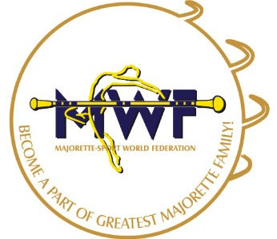

INVITATION
MWF- Meetings
VIENNA/AT,13.-15.01.2017.
E-mail: majorettes.mwf@gmail.com
www.majorettes-mwf.net
SCHEDULE
Friday, 13.01.2017.
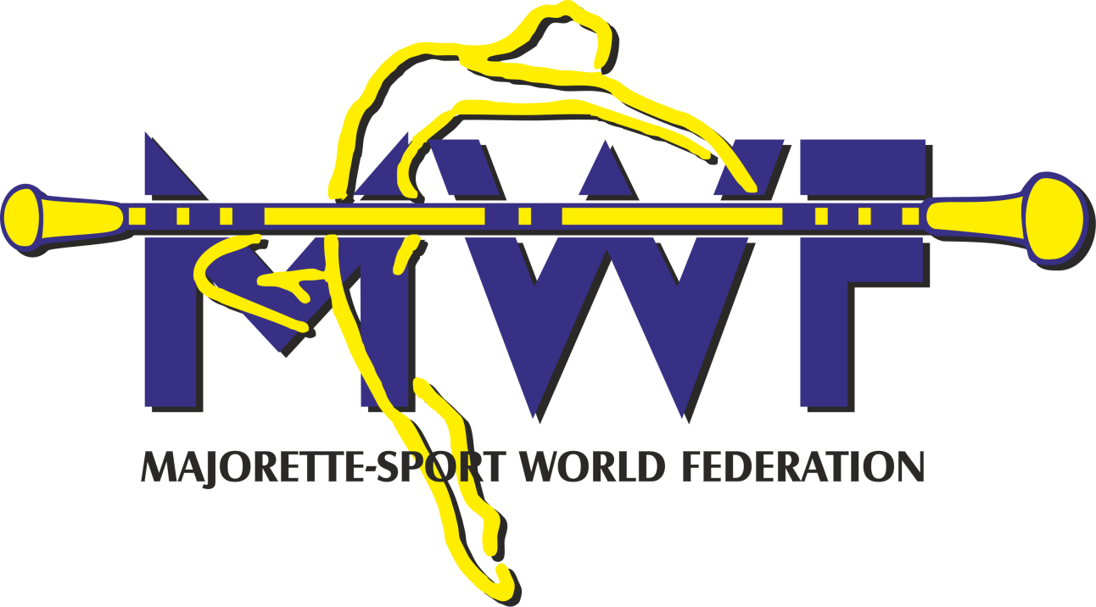
- Competitors Commitee
- Judicial Commitee
- Managament Board

Saturday, 14.01.2017.
- Seminar for international judges
- Exam for international judges

Sunday, 15. 01. 2017.
- General Assembly

ALL PROPOSALS SENT TO 15. November 2016.

Željka Banović
Vienna, 19.10. 2016. President of MWF

