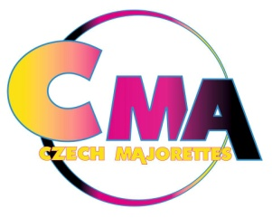
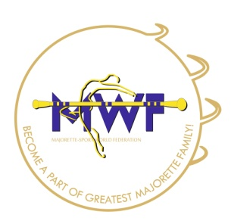
XV. European Championship of Majorette-Sport
Praha 5.- 8. July 2018.

APPLICATION FORM
T-SHIRT
DEADLINE 15. 05. 2018
E-mail: Championship@c-m-a.cz
-payment of 100 % to 15. 05. 2018.
Adress: Fio banka, a.s., V Celnici 1028/10, 117 21 Praha 1
Bank account: 20171210 / 2010
IBAN CZ0720100000000020171210
SWIFT: FIOBCZPPXXX

Country: | TOWN: | CLUB:
Contact person name: | Mobil phone: | Email:
Post adress: |  | Data dor invoice:

size | Kids- 10€ | Woman- 12€ | Man- 12€
134 |  | XXXXXX | XXXXXX
146 |  | XXXXXX | XXXXXX
XS | XXXXXX |  | XXXXXX
S | XXXXXX
M | XXXXXX
L | XXXXXX
XL | XXXXXX | XXXXXX
Woman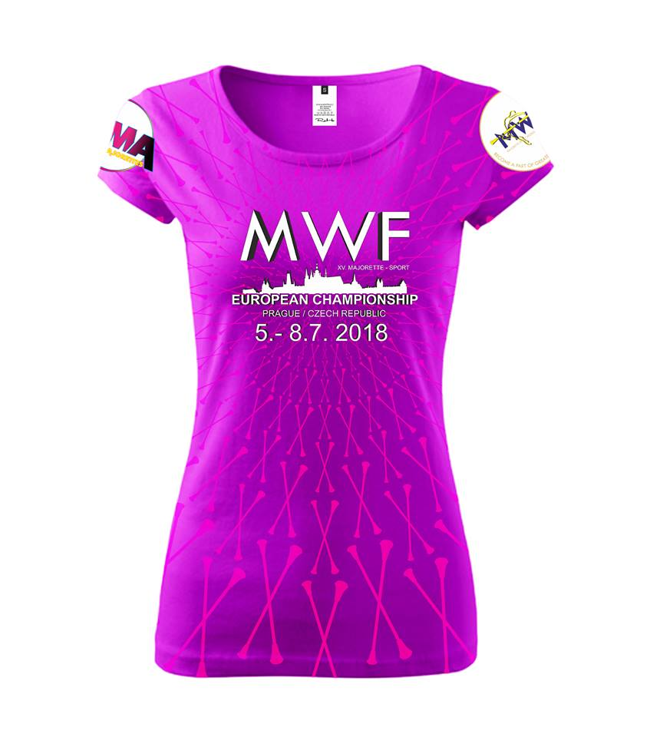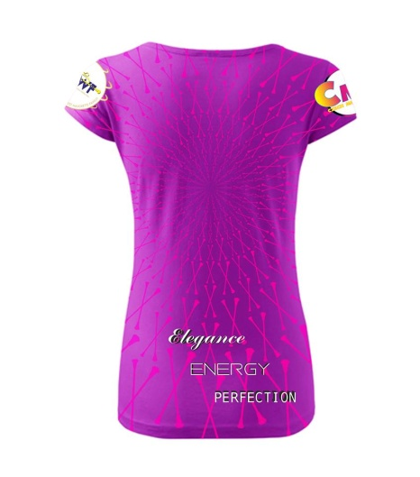

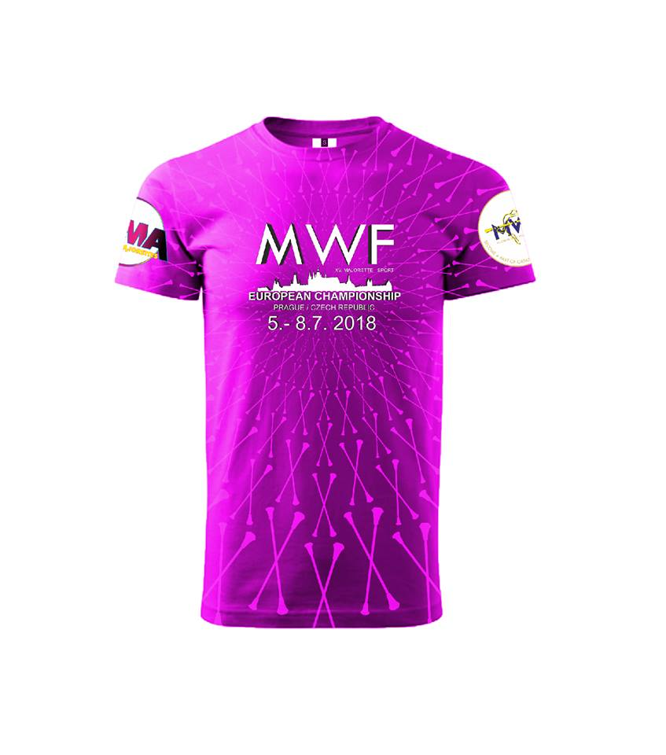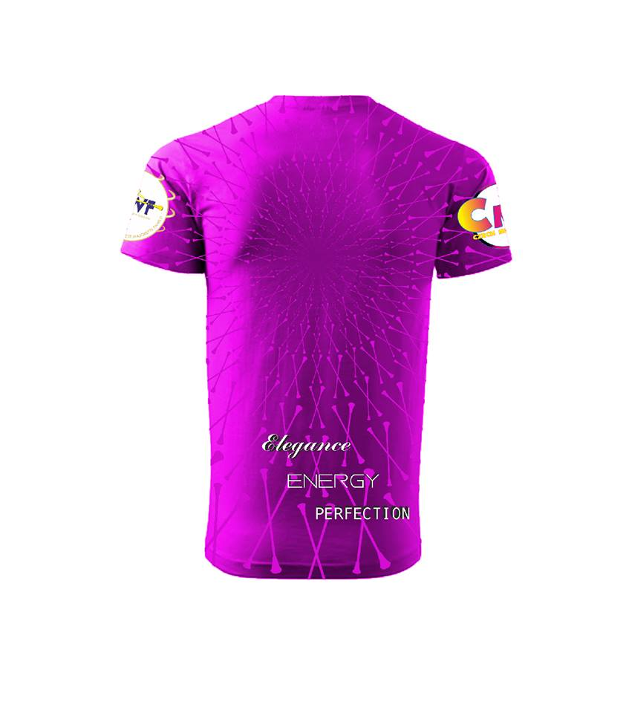
Kids

MAN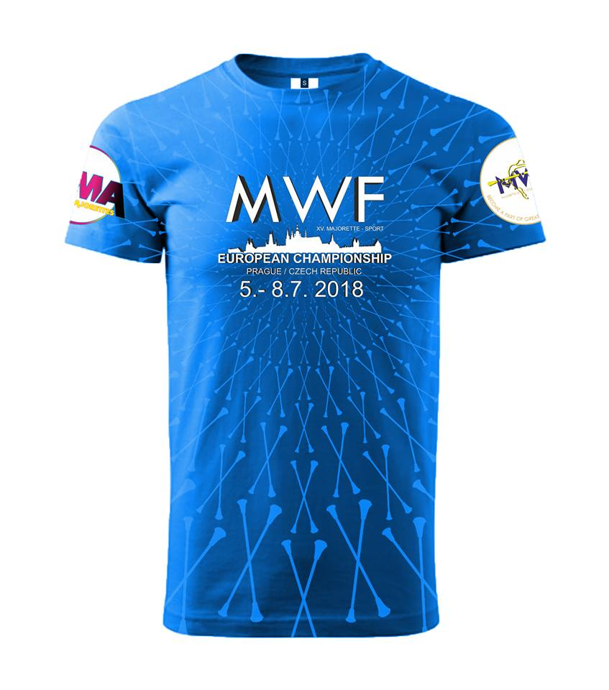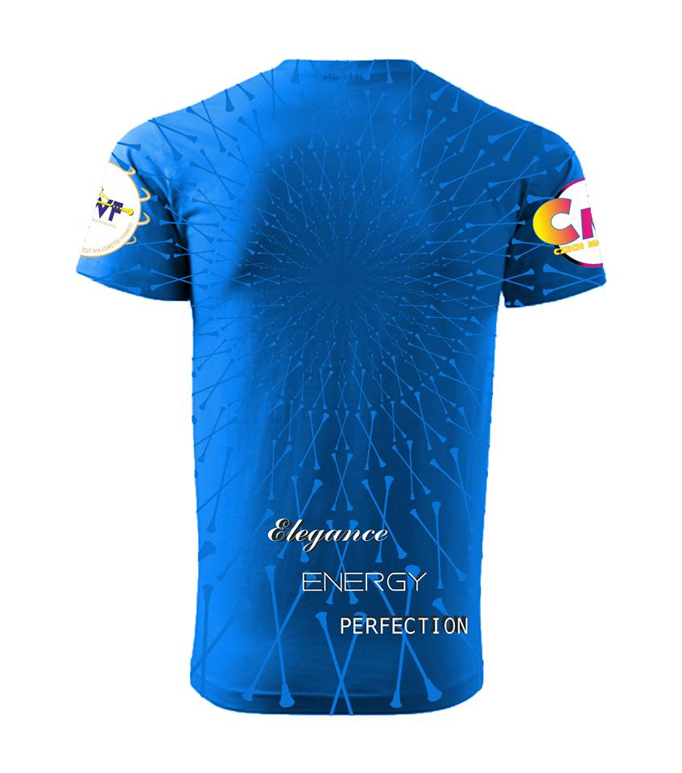

Date:_____________________ ______________________
Signature:

