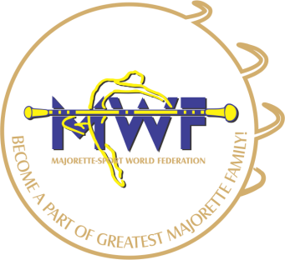
MAJORETTE-SPORT WORLD FEDERATION

MWF-meetings
ACCOMODATION
Bratislava,07.-08.10.2017
NH Bratislava Gate One
Ambrušova 7. 821 04, Bratislava/SK

ACCOMODATION AND FOOD:

ROOMS: | PRICE:
Standard XL single use 1AD | 83,00
Standard XL doublé use 2AD | 93,00

FOOD: | PRICE:
3-course business lunch in the Restaurant | 20,00 EUR

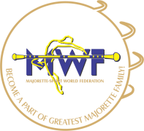
MAJORETTE-SPORT WORLD FEDERATION

APPLICATION FORM
DEADLINE 01. 09. 2017.
E-mail: office@amas.sk
judicalcommitee.mwf1@gmail.com

ACCOMODATION:
DATE: | SINGLE | OTHER

FOOD:
DATE: | LUNCH | DINNER

Signature: Date:

_____________________ _________________

