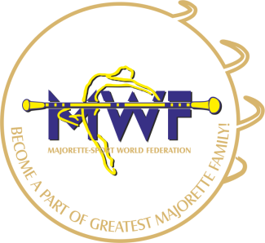
MAJORETTE-SPORT WORLD FEDERATION

MWF-meetings /Opole 13.-14.JANUARY 2018.
ACCOMODATION:
Hotel FESTIVAL
Adresse: Oleska 86 45-222 Opole
E-mail: majorettes.mwf@gmail.com / stanislawrewienski@neostrada.pl
Payment to 05. 01. 2018.
Bank account: 07 1750 0012 0000 0000 2330 8107
IBAN: PL 07 1750 0012 0000 0000 2330 8107
SWIFT CODE: RCBWPLPW

ACCOMODATION
(The price included breakfast and the possibility to use the swimming pool, Parking 0,00 €)
ROOMS: | PRICE:
ROOM FOR 2 & 3 PERSONS  ROOM FOR 4 PERSONS (STUDIO 2+2) | 25 €/PERSON  25 €/PERSON
ROOM FOR 1 PERSON | 37 €/PERSON

FOOD:
FOOD: | PRICE:
DINNER | 15 €/PERSON
SUPPER | 11 €/PERSON
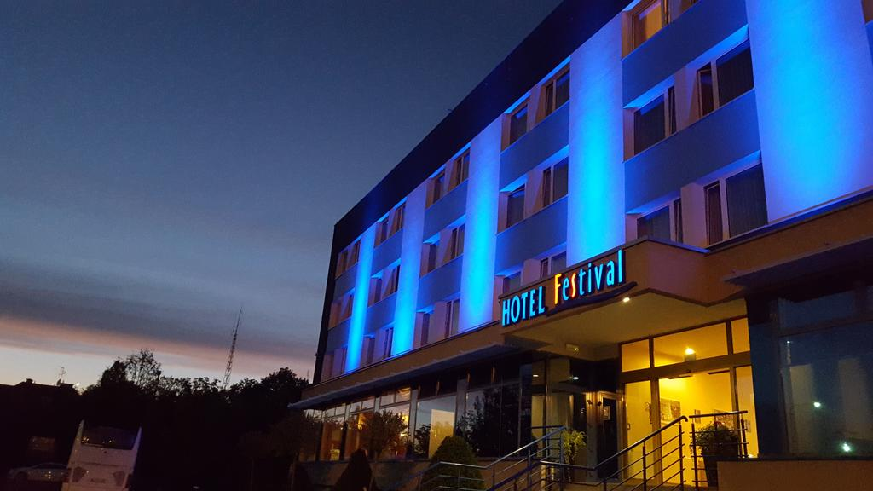

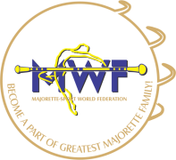
MAJORETTE-SPORT WORLD FEDERATION

APPLICATION FORM
DEADLINE 20. 12. 2017.
E-mail: majorettes.mwf@gmail.com stanislawrewienski@neostrada.pl

DATE: | SINGLE | OTHER
12..-13.01.2018.
13..-14.01.2018
14.-15.01.2018.
ACCOMODATION:

FOOD:
DATE: | DINNER 15 €/PER | SUPPER 11 €/PER
12.01.2018.
13.01.2018.
14.01.2018.
15.01.2018.

Signature: Date:

_____________________ _________________

