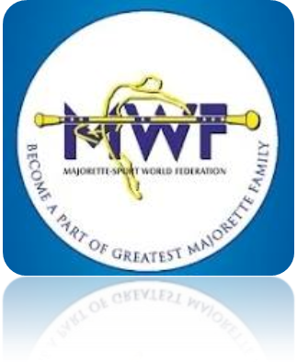

APPLICATION FORM
SEMINAR END EXAM FOR INTERNATIONAL JUDGES
MOSZNA/PL-15.-17.01.2016.
HOTEL MOSZNA ZAMEK
Ul. ZAMKOWA 1, MOSZNA
http://www.moszna-zamek.pl/
DEADLINE - 30 .11. 2015.
E-mail: majorettes.mwf@gmail.com
e-mail: gok@gokdobrzenwielki.pl
www.majorettes-mwf.net

ADMINISTRATIVE BOARD
JUDICIAL COMMITEE
SEMINAR AND EXAM FOR INTERNATIONAL JUDGES
ASSEMBLY

Signature:_________________________________

MWF-MEETINGS/MOSZNA,15.-17.01.2016.
PARTICIPANTS:

Organization:
Country:
Name-function:
E-mail/phone:
ADRESS:
Arriving on:
Number of nights:
Room/s:
Date:
Signature:
E-mail: majorettes.mwf@gmail.com
www.majorettes-mwf.net

