Kazakhstan Federation sport aerobics, majorettes, twirling and artistic dance
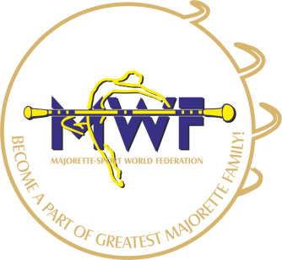
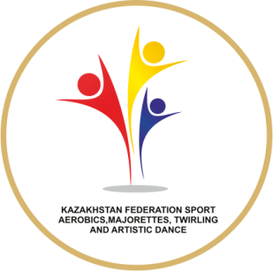

1st Asia Majorette-sport Championship 12-13/2017

Accommodation «Comfort»

Hotel «Almaty» 10,11,12,13,14 august
Breakfast-lunch-dinner
Transfer: Airport-hotel-airport
Sightseeing in Almaty PRICE 210$ 1/person

Accommodation «Economy»

Hostel «DimAl Hostel Almaty» 11,12,13,14,15 august
Breakfast-lunch-dinner
Transfer: Airport-hotel-airport
Sightseeing in Almaty PRICE 95$ 1/person

SCHEDULE

Sch
10 august | 11 august | 12 august | 13 august | 14 august
Arrival | City tour  + Asia Conference | Championships  1st day | Championships  2^{d} day | Departure

