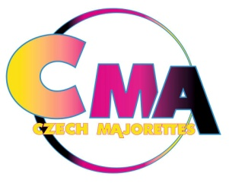
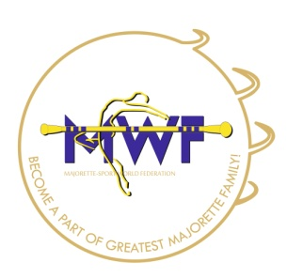
MWF-XV. European Majorette Sport Championship
PRAGUE/CZ, 05.-08.07.2018.

APPLICATION FORM
FOOD
DEADLINE 15. 05. 2018
E-mail: Championship@c-m-a.cz
-payment of 50% to 15. 05. 2018.
- all 15. 06. 2018
Adress: Fio banka, a.s., V Celnici 1028/10, 117 21 Praha 1
Bank account: 20171210 / 2010
IBAN CZ0720100000000020171210
SWIFT: FIOBCZPPXXX

Country: | TOWN: | CLUB:
Contact person name: | Mobil phone: | Email:
Post adress: |  | Data dor invoice:

Food
 | Wednesday | Thursday | Friday | Saturday | Sunday
Breakfast
3€
Lunch
5€
Dinner
5€

Vegetarian diet
 | Wednesday | Thursday | Friday | Saturday | Sunday
Breakfast
3€
Lunch
5€
Dinner
5€

Gluten free
 | Wednesday | Thursday | Friday | Saturday | Sunday
Breakfast
3€
Lunch
5€
Dinner
5€

Date:_____________________ ______________________
Signature:

