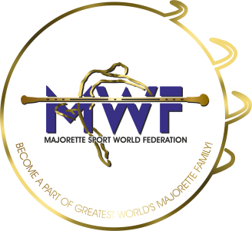
MAJORETTE SPORT WORLD FEDERATION

SEMINAR OF MAJORETTE SPORT
LUXEMBOURG/ 31.01.-02.02.2020.

PROGRAMME:

FRIDAY, 31.01.2020.
14:00 – 18:00 THEORETICAL PART

- MWF history
- Presentationof MWF organization as a global federation
- Introductionof MWF system ofcompetition
- Presentationof program for educationofnationallicensedcoachesandjudges
- MWF rulebook: introducingbasicrules, competitivecategories, compulsoryelements, levelsofworkwithequipment
- COMPETITIVE CATEGORIES:
  - BATON SOLO FORMATIONS (SOLO, DUO-TRIO, MINI FORMATION)
  - BATON CHOREOGRAPHY
  - BATON DEFILE
  - POM PON SOLO FORMATIONS (SOLO, DUO-TRIO, MINI FORMATION)
  - POMPON CHOREOGRAPHY
  - POMPON DEFILE
  - BATONFLAG

14:00 - 18:30 PRACTICAL PART

- Warm-up
- Levelsofworkwith BATON
- Work on BATON CHOREOGRAPHY

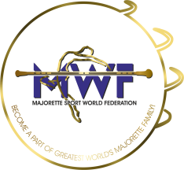
SATURDAY, 01.02.2020.
09:00 – 13:30 PRACTICAL PART
- Warm-up
- LevelsofworkwithBATON
- Work on BATON elements
- Work on BATON CHOREOGRAPHY

LUNCH BREAK

14:30 - 18:30 PRACTICAL PART
- Warm-up
- LevelsofworkwithPOM PON
- Work on POM PON elements, liftings, waves, patterns
- Work on POM PON CHOREOGRAPHY
SUNDAY, 02.02.2020.

10:00 – 13:00 PRACTICAL PART
- Warm-up
- Work on compulsoryelementsof BATON and POM PON
- Work on gymnasticandacrobaticelements

LUNCH BREAK

14:00 – 17:00 PRACTICAL PART
- Levelsofworkwith BATONFLAG
- Work on BATONFLAG elements
- Work on BATONFLAG CHOREOGRAPHY

