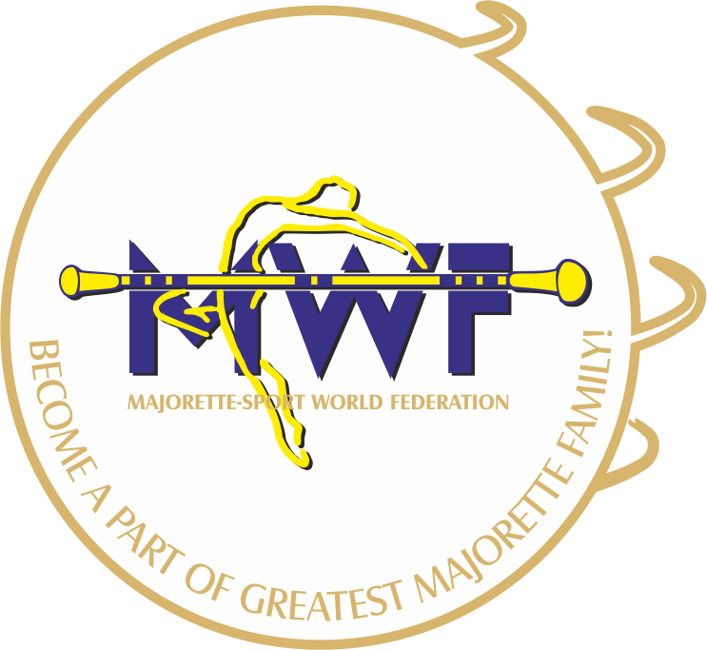
MAJORETTE-SPORT WORLD FEDERATION

APPLICATION FORM
Opole /POLAND
13.-14.01.2018
Hotel FESTIVAL / Oleska 86 /45-222 Opole
DEADLINE - 15 .12. 2017.
E-mail: majorettes.mwf@gmail.com
www.majorettes-mwf.net
MANAGAMENT BOARD
JUDICIAL COMMITEE
COMPETITORS COMMITEE
SEMINAR AND EXAM FOR INTERNATIONAL JUDGES
ASSEMBLY

Signature:_______________________________
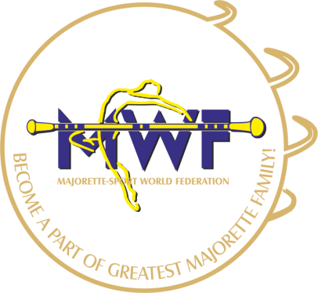

MWF-meetings
Opole /POLAND, 13.-14. 01. 2018.
PARTICIPANTS:
Organization:
Country:
Name-function:
E-mail/phone:
ADRESS:
Arriving on:
Number of nights:
Room/s:
Date:
Signature:

