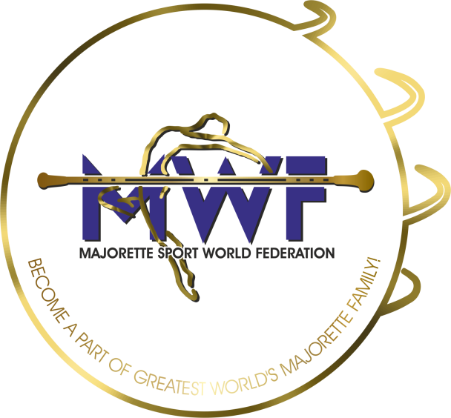
MAJORETTE-SPORT WORLD FEDERATION
IN 83376718186
RN 4078942
IBAN: HR4324020061100809283
SWIFT: ESBCHR22
E-mail: mwf.majorettes1@gmail.com
Mob:00385 95 960 6669
www.majorettes-mwf.net

SCHEDULEHEDULE

Saturday/29.01.2022
- HOTEL SHERATON/Zagreb

- 10.00-Competitors Commitee

- 12.00-Judicial Commitee

- 13.00-Lunch

- 14.00-Judicial Commitee

- 15.30-Commitee for education

- 16.30-Commitee for media promotion

- 17.30-Managament Board

Sunday/30.01.2022.

- 09,00- Assembly
- 12,00-Lunch

