MAJORETTE-SPORT WORLD FEDERATION
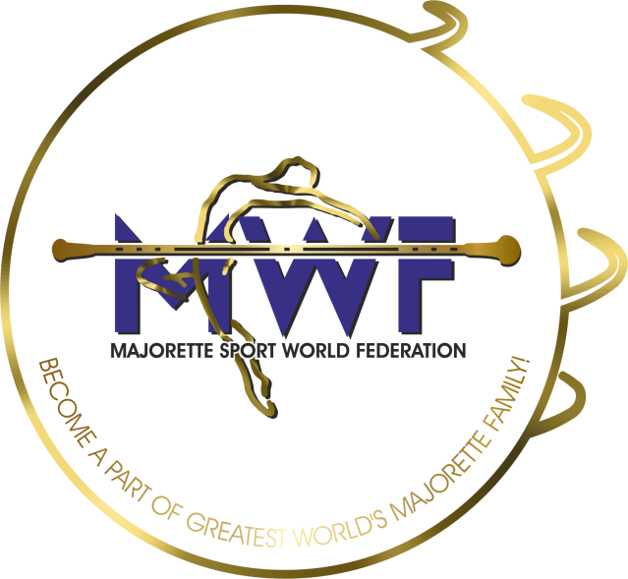

MWF meetings
APPLICATION FORM
DEADLINE – 01.10.2022.
E-mail: mwf.majorettes1@gmail.com / judicalcommitee.mwf1@gmail.com

ONLINE
MANAGAMENT BOARD
JUDICIAL COMMITEE
COMMITEE FOR EDUCATION
SEMINAR FOR INTERNATIONAL JUDGES
ASSEMBLY

Signature:____________________________
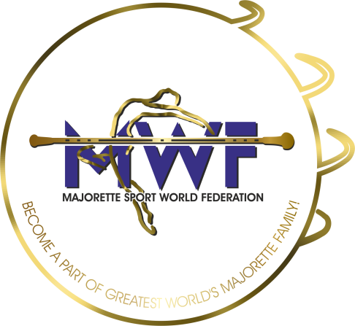

MWF-meetings
Brno-CZ/15.-16.10.2022.-19.01.2020. PARTICIPANTS:
Organization:
Country:
Name-function:
E-mail/phone:
ADRESS:
Arriving on:
Date:
Signature:

