MAJORETTE-SPORT WORLD FEDERATION
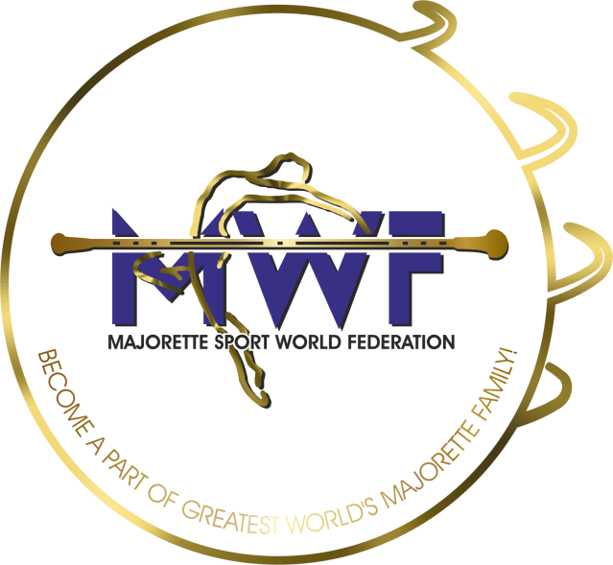

MWF meetings
Hradec Kralove-CZ/19.-22.01.2024.
APPLICATION FORM
DEADLINE – 25.12.2023.
E-mail: mwf.majorettes1@gmail.com / judicalcommitee.mwf1@gmail.com

ONLINE
MANAGAMENT BOARD
JUDICIAL COMMITTEE
COMMITTEE FOR EDUCATION
SEMINAR AND EXAM FOR INTERNATIONAL JUDGES/new canidates
ASSEMBLY

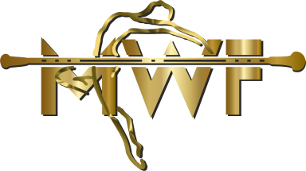
Signature:____________________________
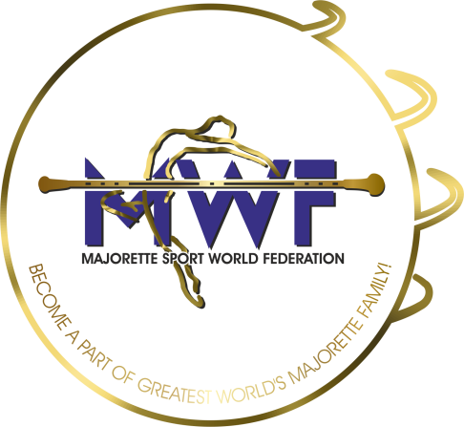

MWF-meetings
Hradec Kralove-CZ/19.-22.01.2024. 19.01.2020. PARTICIPANTS:
Organization:
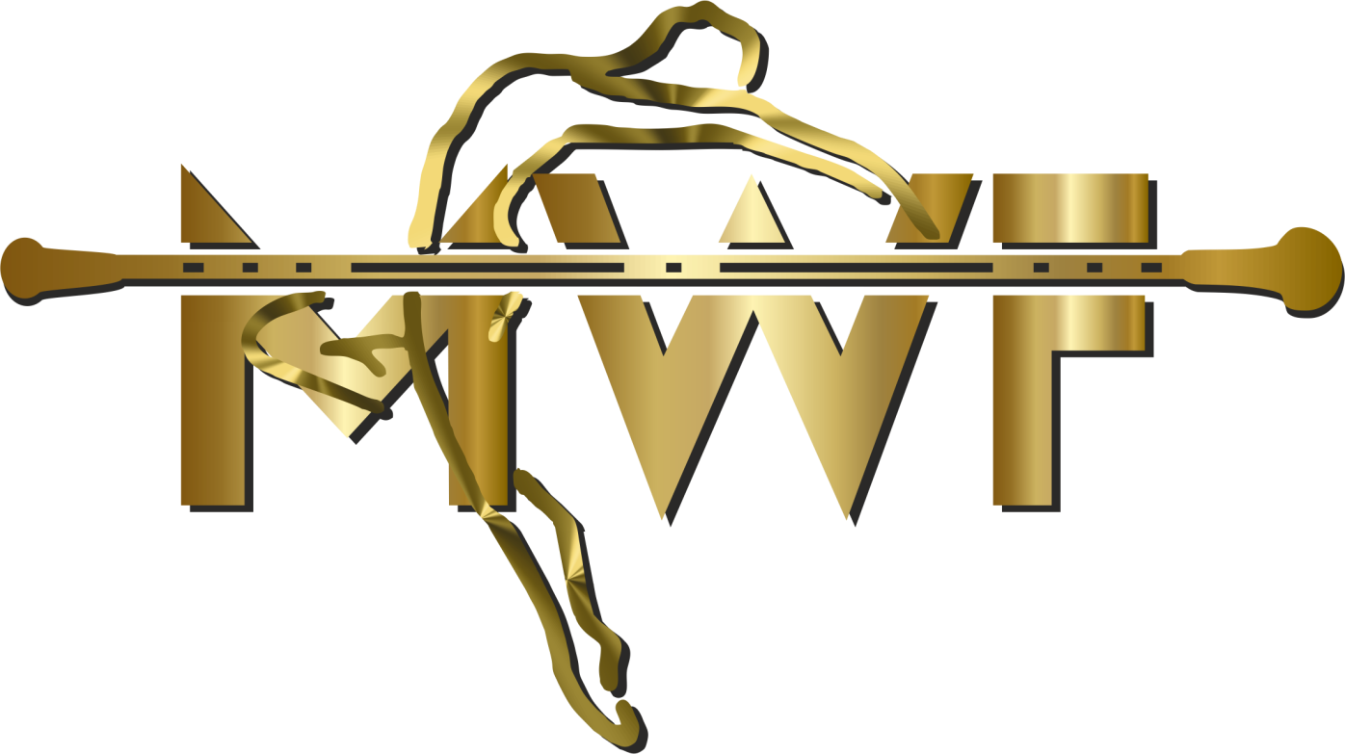
Country:
Name-function:
E-mail/phone:
ADRESS:
Arriving on:
Date:
Signature:

