MAJORETTE-SPORT WORLD FEDERATION
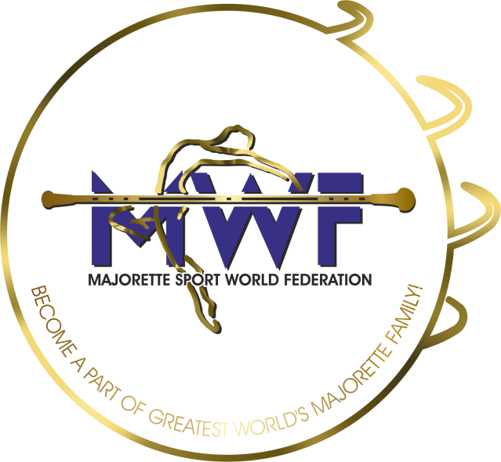

MWF meetings
Prešov-SK/20.-22.10.2023.
DEADLINE – 05.10.2023.
E-mail: mwf.majorettes1@gmail.com / judicalcommitee.mwf1@gmail.com

APPLICATION FORM

ONLINE
MANAGAMENT BOARD
JUDICIAL COMMITTEE
COMMITTEE FOR EDUCATION
MEETING- INTERNATIONAL JUDGES

Signature:____________________________
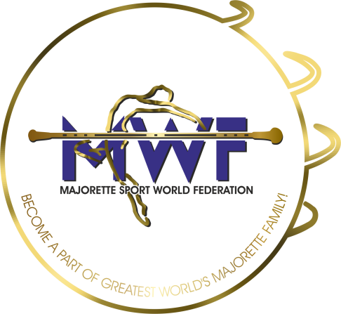

MWF-meetings
-19.01.2020.PARTICIPANTS:
Organization:
Country:
Name-function:
E-mail/phone:
ADRESS:
Arriving on:
Date:
Signature:

