MAJORETTE-SPORT WORLD FEDERATION
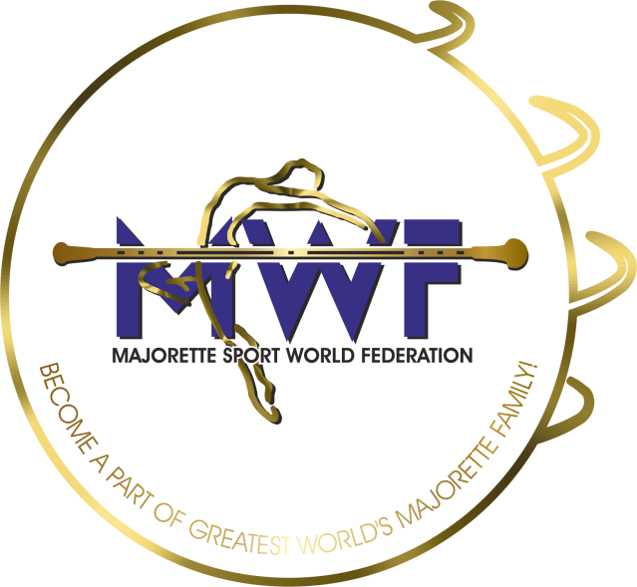

VIENNA/AT, 17.-19.01.2020.
APPLICATION FORM
DEADLINE – 25.12.2019.
E-mail: majorettes.mwf@gmail.com / judicalcommitee.mwf1@gmail.com
www.majorettes-mwf.net / www.majorettes-mwf.eu

MANAGAMENT BOARD
JUDICIAL COMMITEE
COMPETITORS COMMITEE
COMMITEE FOR EDUCATION
COMMITEE FOR MEDIA PROMOTION
MEETING FOR INTERNATIONAL JUDGES
ASSEMBLY

Signature:______________________________

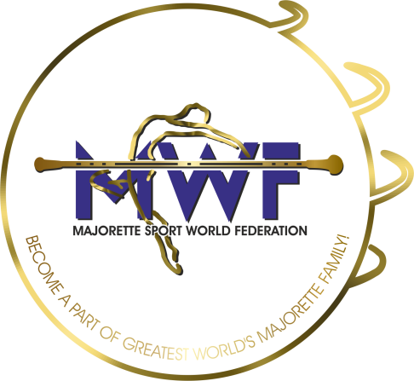

MWF-meetings
VIENNA/AT,17.-19.01.2020.
PARTICIPANTS:
Organization:
Country:
Name-function:
E-mail/phone:
ADRESS:
Arriving on:
Number of nights:
Room/s:
Date:
Signature:

